

SCHOOL OF COMPUTING AND INFORMATICS
BACHELOR OF SCIENCE IN INFORMATION TECHNOLOGY
UNITE TITLE: ADVANCED CRYPTOGRAPHY
UNITE CODE:
PROJECT TITLE: SECURITY AND ENUMERATION

SUBMITTED BY: MAINA JOSHUAREG. NO: BSCCS/2024/47667
SUPERVISOR: MR. MICHAEL NYORO

ADVANCED CRYPTOGRAPHY
SELECTED TECHNOLOGIES
ONLINE PORTFOLIO
Work has been uploaded across Github
https://github.com/Main-Josh/BIT4138_Advanced_Cryptography

Table of Contents
A Pseudorandom Sequence generator in Python 2
Mini Research Report 3
1. One-Time Pad (OTP) 3
RC4 Stream Cipher 3
Real-World Applications 4
MODIFIED XOR PROGRAM 4
MENU DRIVEN STREAM CIPHER APPLICATION 5

A Pseudorandom Sequence generator in Python
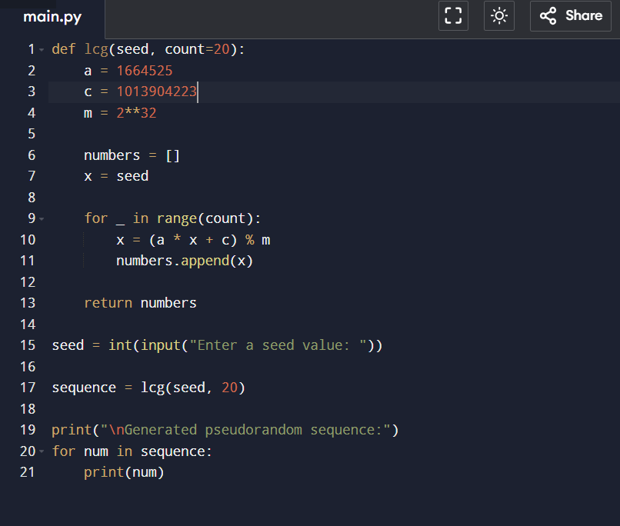
Figure 1Pseudo random generator
Utilisation of the same seed value outputs Similar values
Period
The generator can have a maximum period of 2³² (4,294,967,296) values before the sequence repeats, which is much longer than the 20 values generated.
Randomness Observations
The numbers appear random with no obvious short-term pattern.
The same seed always produces the same sequence.
Different seeds produce different sequences.
It is suitable for basic simulations but not for cryptographic use because it is predictable.

Student Reflection

Week 2

Mini Research Report

1. One-Time Pad (OTP)

The One-Time Pad (OTP) is an encryption technique that uses a random key that is the same length as the message. Each character of the plaintext is combined with the corresponding character of the key to produce ciphertext.
Advantages
- Provides perfect secrecy when used correctly.
- Impossible to crack through brute force.
Disadvantages
- Requires a truly random key.
- Key must be as long as the message.
- Secure key distribution is difficult.
Real-World Applications
Military and diplomatic communications.
Highly sensitive data transmission where maximum security is required.
due to security weaknesses and replaced by stronger encryption algorithms.

RC4 Stream Cipher
RC4 is a stream cipher developed by Ron Rivest in 1987. It generates a pseudorandom keystream that is combined with plaintext using the XOR operation to create ciphertext.
Advantages
- Fast and simple to implement.
- Requires low computational resources.
Disadvantages
- Vulnerable to several cryptographic attacks.
- No longer considered secure for modern applications.

Real-World Applications
Previously used in SSL/TLS and WEP.
Largely deprecated due to security weaknesses and replaced by stronger encryption algorithms.

MODIFIED XOR PROGRAM
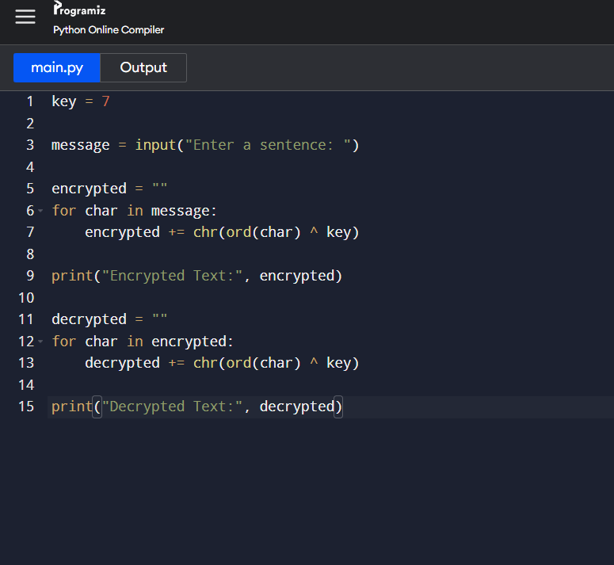
Figure 2 Modified XOR Program

Student Reflection

MWeek 3

MENU DRIVEN STREAM CIPHER APPLICATION
We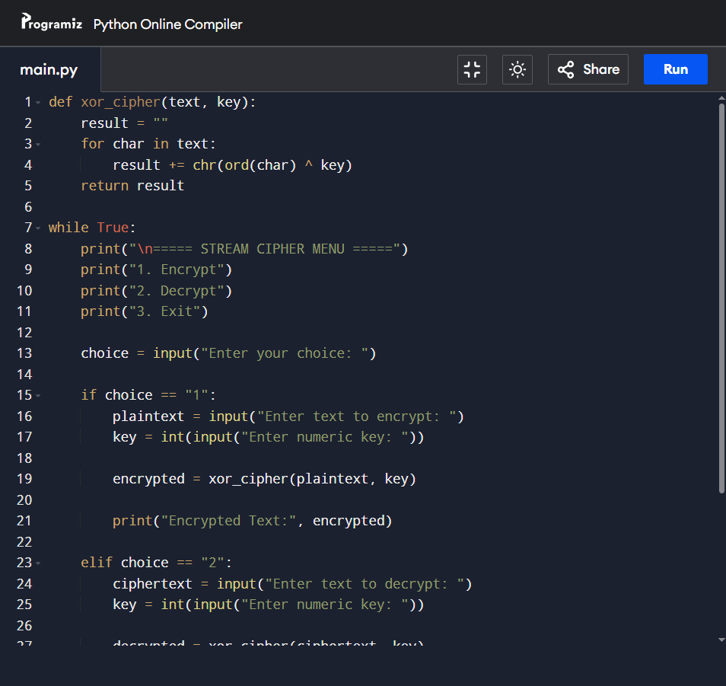
Figure 3 MENU DRIVEN STREAM CIPHER APPLICATION

Student Reflection

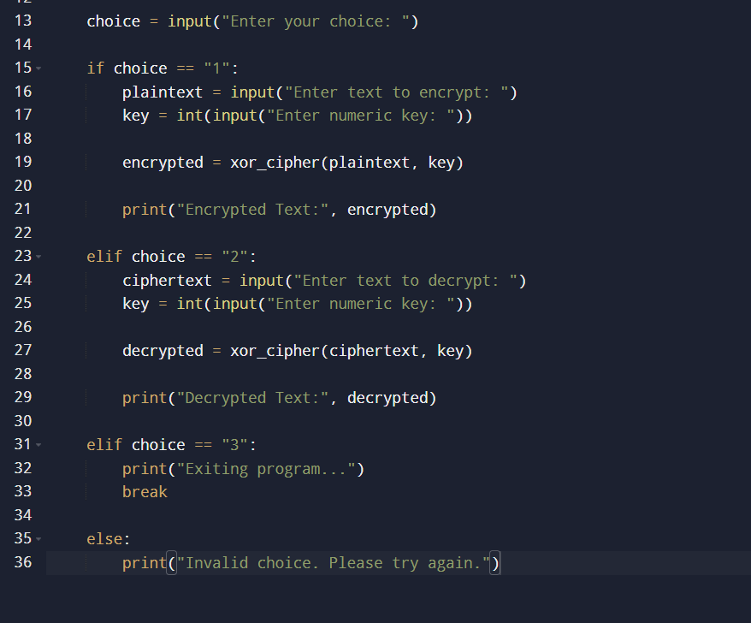

Week 4

A randomness Testing program

GEneratees 100+ random Bits

Performs Statistical Tests

Displays interparatations

Importnce of Randomness

Weak Random Genarators

Historical Crytographic Failures

Student reflection

Week 5
A simple Block Cipherr Simulation Program
It performs the following
Block Division
Sunstituition
Permutation
Multiple block handling

Mini Research report
DES
AES
Feistel Structure
Confusion and diffudion

Week 6

A simple SPN implementation in Python
User enters plaintext
APpply substituition
Apply Permutation
A\Display Cipheer tect
Non Linearity Invertigation
What is non_linearity?
Why is it impprtant in crptography?
How do S- Boxes create Non-linearity

SPN Secutrity evaluation
Compare
SPN Structure
Feistel structure
Evaluate
Security
Performance
Ease of implementation
Modern Usage

Week 7

Differnettial Cryptanalysis Simulation
Develop a pyhon program that
Accepts twplain textinputs
Computes Differences
Display observations

Mini AES inspired encryption simulator that includes
Key mixing
Substitution
Permutation
Multiple Rounds
Block Cipher Security Research
Research and explaijn
Differential Cryptanalysis
Linear Crptanalysis
Algebraic Attacks
Real world Examples
Crate A Block Cipher Security Analyzer
Features include Avalanche Effect Testing
Differential Analysis
Frequent Distribution
Statistical Reporting

